CSYE 7280 User Experience Design and Testing

**Advanced Prototypes**

**Team Name: CareConnect**

| **NU ID** | **Team Member Name** | **Contribution** |
| --- | --- | --- |
| 002713929 | Habeebuddin Mir | Design thinking and prototype development |
| 002778147 | Maseerah Khatoon | Design thinking and prototype development |
| 002796856 | Shaiz Akhtar | Design thinking and prototype development |

**Supervisor – Prof. Svetlena Taneva Metzger, PhD**

Master of Science in Information Systems

College of Engineering

Northeastern University, Toronto

**Introduction**

After a comprehensive evaluation and study of the low fidelity prototypes, we developed this advanced prototype that leverages the feedback and learnings from the user interviews and feedback. This version of the prototype enhances prototype Charlie by incorporating the best of prototype Alpha and Bravo while retaining the original design that proved to be useful.

Continuing the previous task goals, we focus on the 4 major features:

1. Login and Sign Up
2. Build Profile
3. Search and View Doctor profiles
4. Book appointments

Interactive Prototype Link:

<https://www.figma.com/file/UJ4F6bOLmMgJUSJe5NvX2s/Advanced-Prototype?type=design&node-id=0%3A1&mode=design&t=1W7MqhVJPftyZwxZ-1>

Following pages will discuss each modified task screen and the reasoning behind the changes.

1. **Login and Sign Up Screens:**

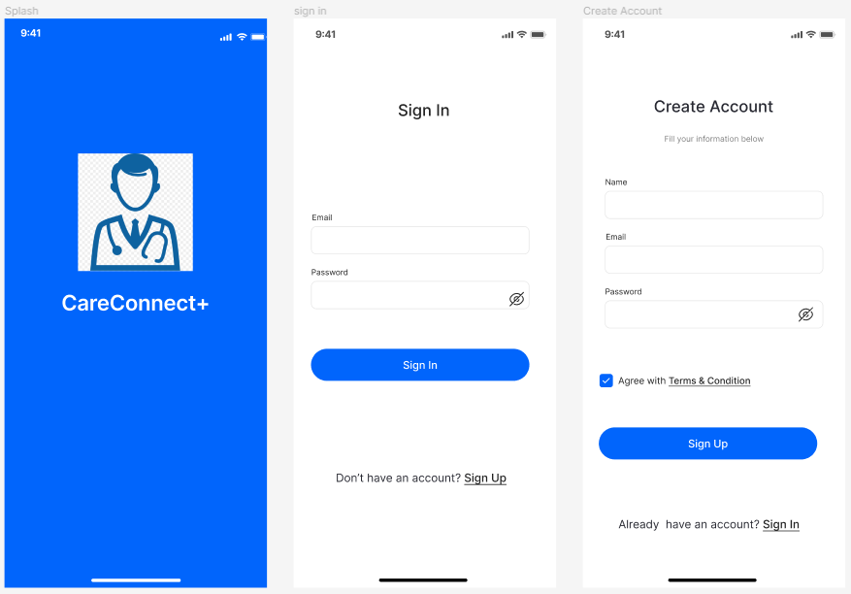

We start off with the launch screen of the app that leads to a sign in screen where the user is asked for their credentials. In case a new user launches the app, they are directed to create an account with their email and a password. Once a user hits sign in after entering correct credentials, the screen is populated with the home screen of the app.

Previously when a new user wished to sign up, we had more fields to fill in by the user. But as users’ suggested, we reduced the number of screens they need to go through before moving to the main screen. In this prototype, we have designed these screens to be quite clear and simple to start with the app as per the users preference so that they are not overwhelmed right at the start.

In the initial prototypes, we had missed creating a login page too, assuming everyone to be new users, but a login page has now been added after users requested one in the last session.

1. **Build Profile:**

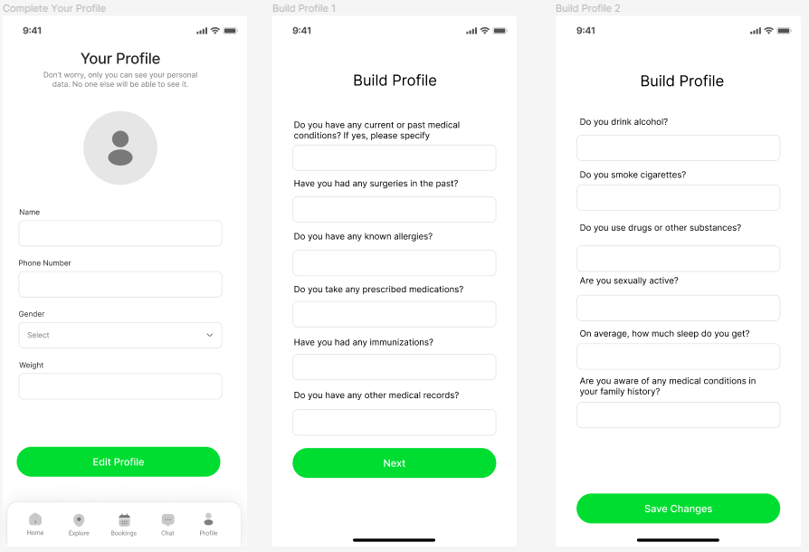

As mentioned in the previous screen description, users preferred making the sign up process shorter, which led us to create the build your profile separately.

It was also pointed out that the language used was either too technical or vague, which prompted us to go with more user friendly terms. A right balance between the number of questions and the number of screens were also considered a lot. We ended up with a substantial number of questions perfectly fit onto 3 screens.

While this section may not be perfect, it qualifies well as a medium fidelity prototype.

1. **Search for a Doctor**

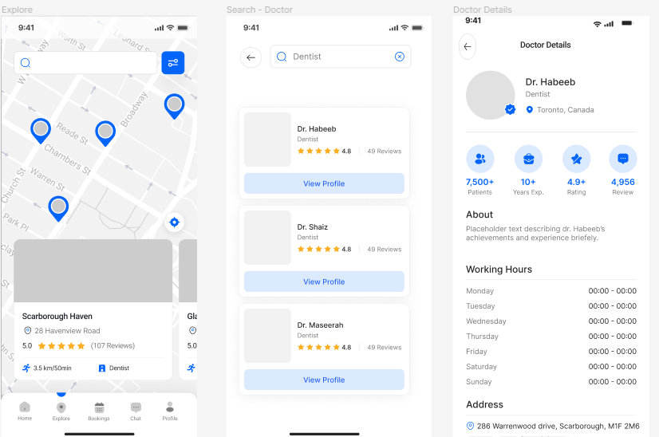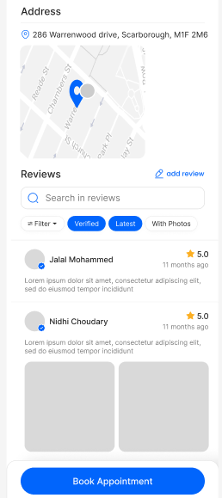

Apart from the evident addition of colors and graphics, we added the much sought out navigation bar to the main screen. We also added a map along with close by location suggestions which makes our search screen more dynamic.

After searching up a speciality, users are given a list of doctor profiles in a card format that highlights the speciality and ratings of the doctor. It also provides users an action button to view a detailed profile of a doctor that they might be interested in.

Clicking on the ‘View Profile’ button directs the users to a comprehensive page that displays out all the essential information of a doctor one might possibly need. The information is not only aesthetically presented but also well structured highlighting critical content and summaries. The icons highlight achievements and experience of a doctor in an easy to grasp graphical way.

After the user has gone through the profile, they will encounter a ‘Book Appointment’ action button that redirects them to the screens discussed next.

1. **Book Appointment**

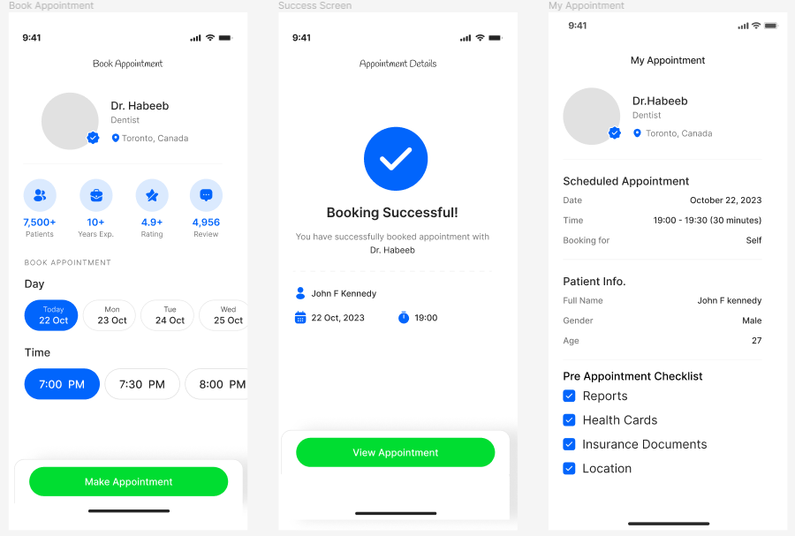

When a user decides to book an appointment with a doctor the above screen is shown up which allows the user to select a date and time for the appointment. Once the user taps the “Make Appointment” button a confirmation screen comes up with the appointment details.

During our evaluations with the earlier prototype, we had received feedback for the addition of a confirmation page which has been added here. Once an appointment is confirmed, the users can easily view the booked appointment under their bookings feature which gives a summary of their appointment and also we have included a checklist of documents or information that the user might need to share before their consultation.

Another critical aspect users pointed out was the need for fewer and more simpler steps during booking. That was considered into our design planning, making it the reason behind the button groups that can be seen for choosing date and times. We have designed the booking process to be convenient and easy to follow according to the users’ insights we concluded with our evaluations earlier.